Ramadan Charity Event | Title
12/4/2021-14/4/2021 | Date
Faculty of Engineering | Location
2 Days | Duration
Dr. Mohamed Kamal, Mr. Ahmed Rashed, Eng Amr Mukhaimer | Organizer
The first official event for Horus Ambassadors. The idea behind it was to make the spirit of Ramadan spread all over the faculty. | Paragraph

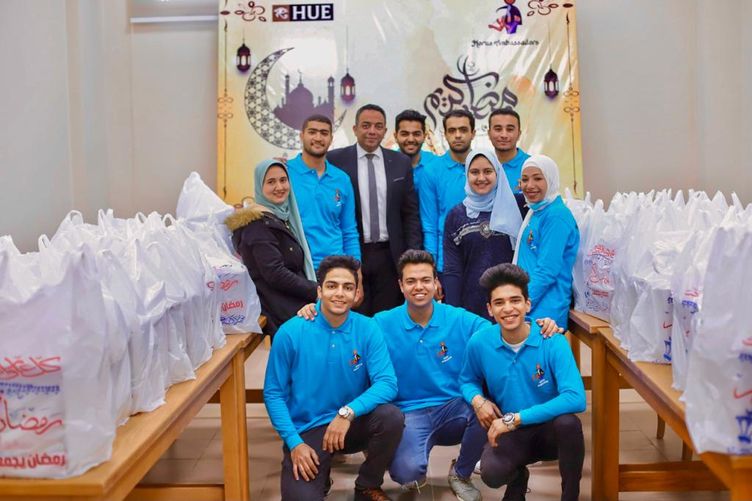

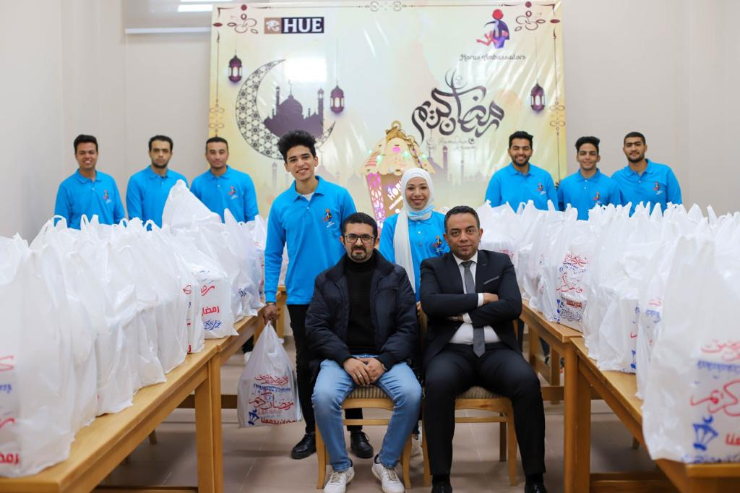

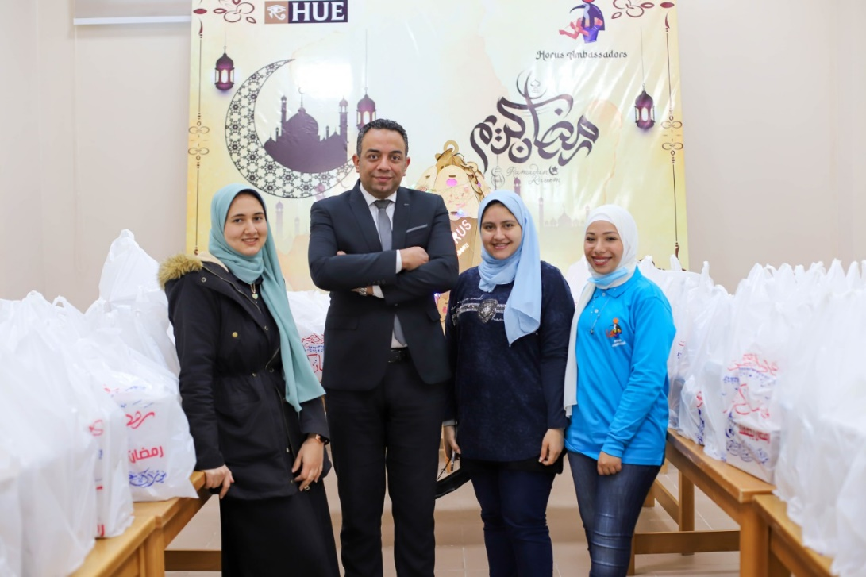

Ramadan Event | Title
18/4/2021-21/4/2021 | Date
Faculty of Engineering | Location
3 Days | Duration
Dr. Mohamed Kamal | Organizer
The idea behind this event was to spread happiness in the faculty. Students, Faculty Workers, and The Academic Staff were all involved in this event. The event was recorded by video and released on Facebook. | Paragraph

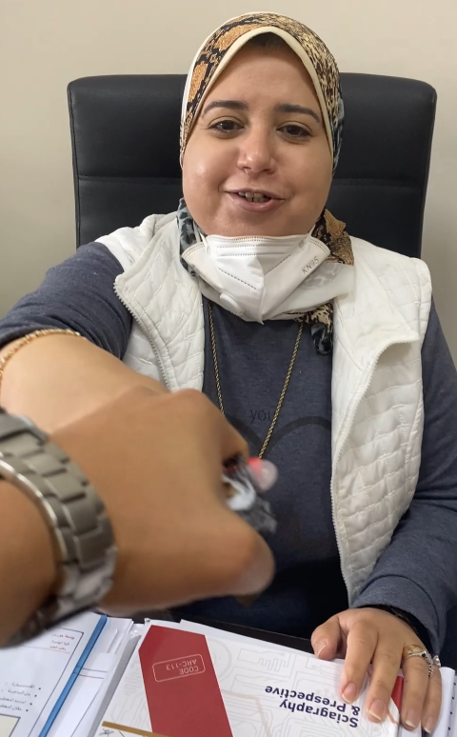

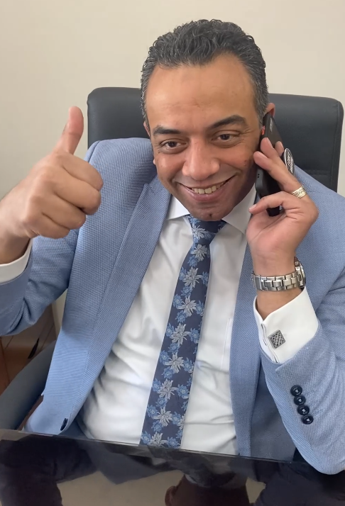

Clothes Charity Event | Title
11/5/2021-13/5/2021 | Date
Damietta | Location
3 Days | Duration
Dr. Mohamed Kamal | Organizer
As the Eid was coming in, we had to give back to the less fortunate in order to spread the happiness of Eid. | Paragraph

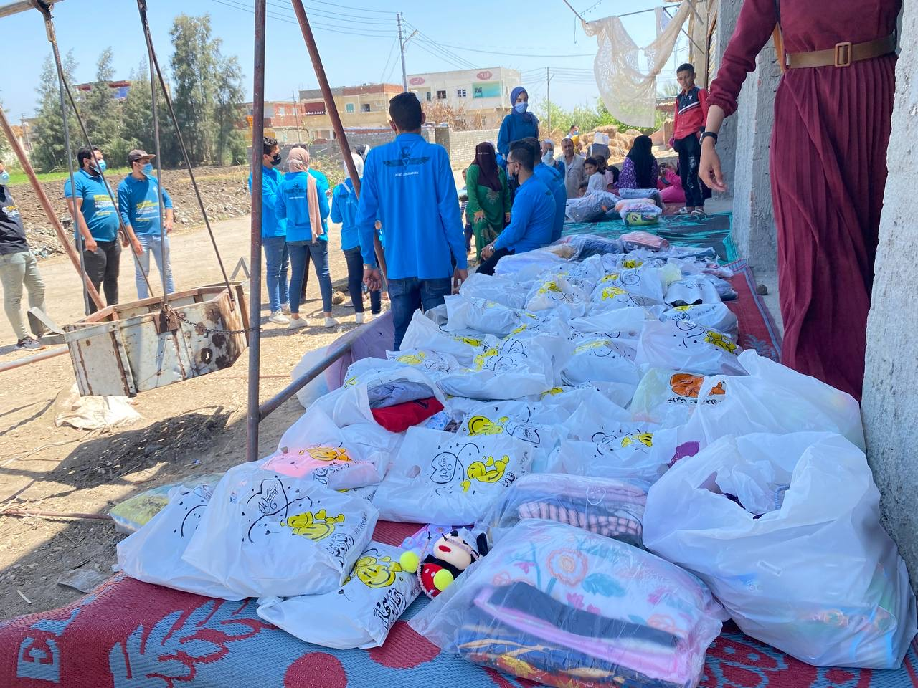

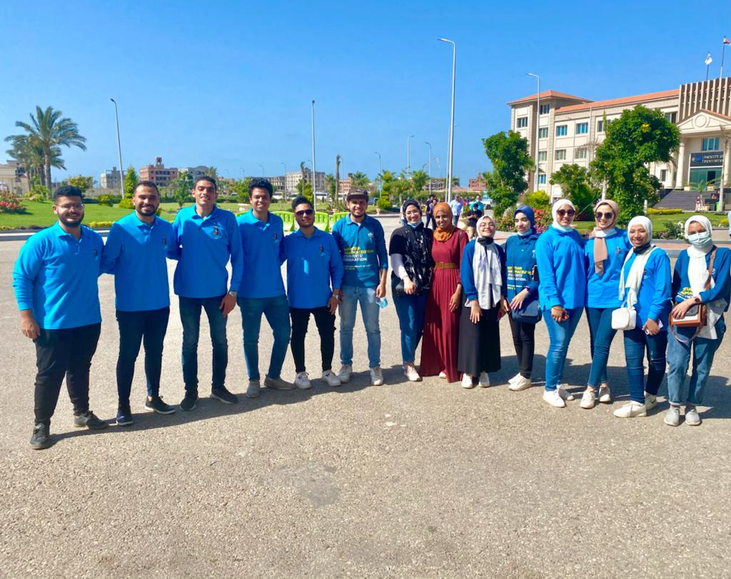

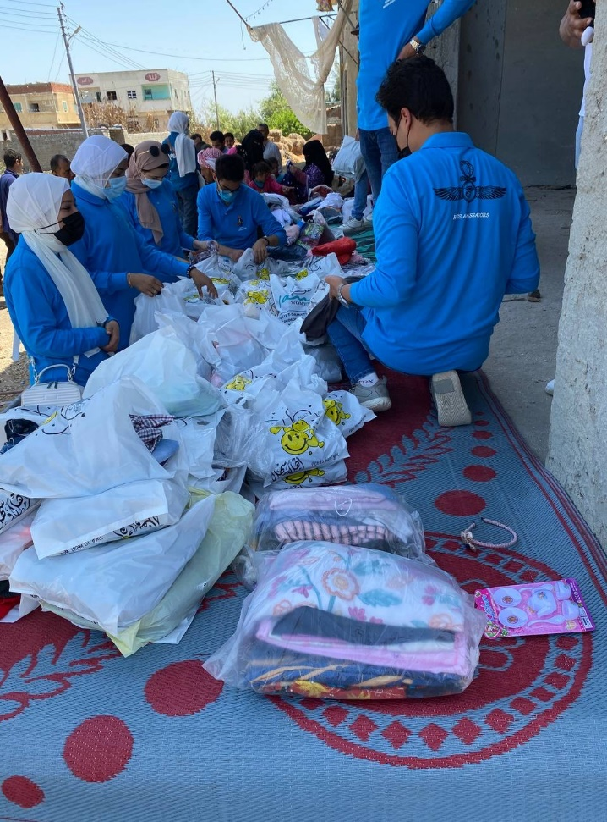

Horus Ambassadors Honoring the University’s Board | Title
1/7/2021 | Date
Horus University | Location
1 Day | Duration
Dr. Mohamed Kamal | Organizer
The team honored the extraordinary work done by the University’s Board. The team gave honor to :  Dr. Elsaid M. Abdel-Hady  Dr. Hassan ElShenawy  Dr. Mohamed Dabaon  Dr. Amira Almaz  Dr. Riham Salah  Eng. Abd Elrahman Elawendy | Paragraph

